# Core Features:

There are various features used in the project and each will be explained briefly.

## Collision Detections:

The game comprises of both, box, and sphere collisions. Box collisions are used for objects to collide and halt their movement. Sphere collisions are used for combat because the weapon’s scale values prevented from producing reasonable results when done with it box. The equations are displayed in Code Snippets 1, 2, and 3. The implementation can be seen in Screenshot 1.

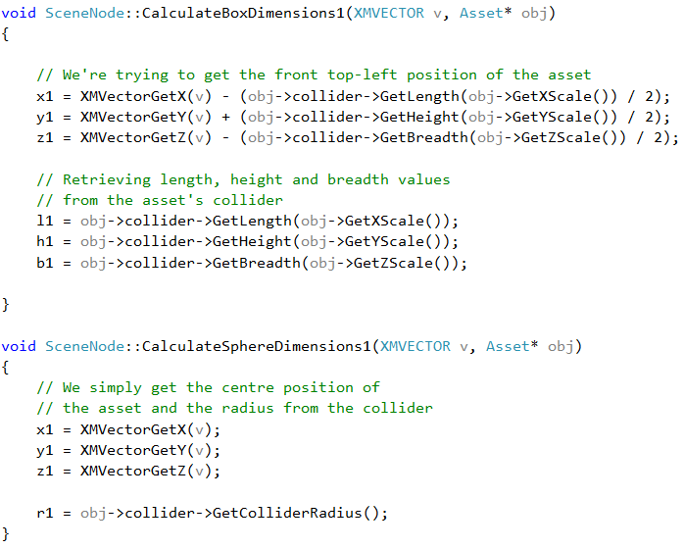

Code Snippet 1. Calculating values for respective collisions

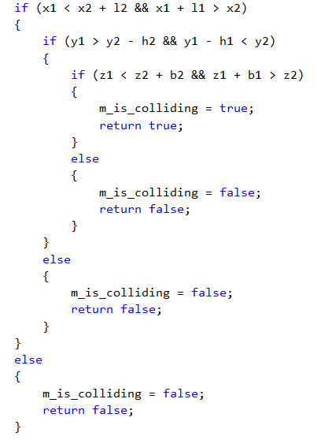

Code Snippet 2. Box Collision Checks

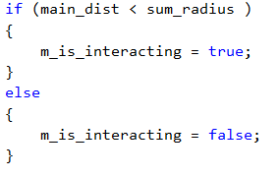

Code Snippet 3. Sphere Collision Check

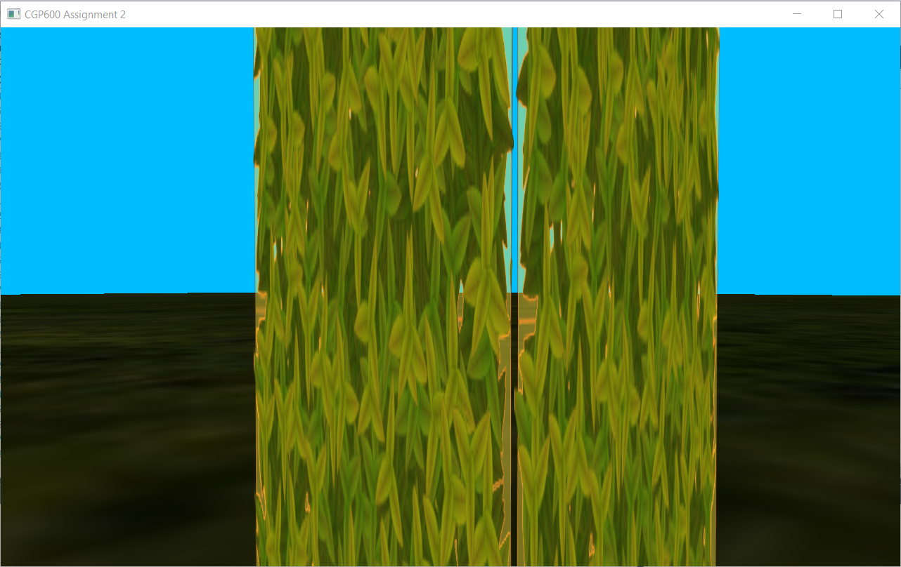

Screenshot 1. Player colliding with a Tree

## Scene:

Every object in the game is a child of one abstract root node. Drawing of all objects is performed by calling the draw function of the root node and it will continue to call its children’s draw functions as well (see Code Snippet 4). The player can also equip and drop weapons which translates to adding (pushing back to a children vector) and detaching as a child of the player (erasing from the children vector). The same logic is applied for the moving block as well. The implementation can be seen in Screenshots 2 and 3.

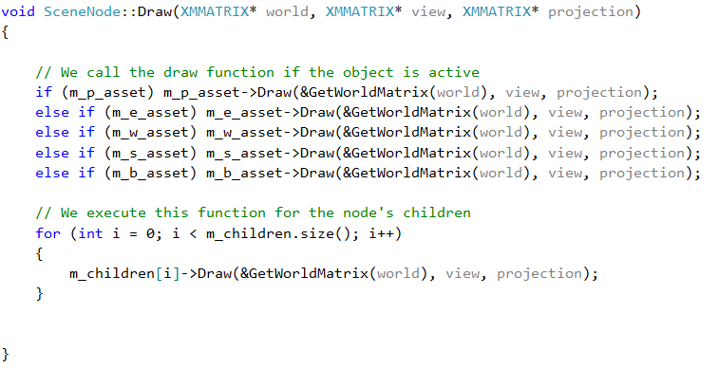

Code Snippet 4. Drawing of Scene

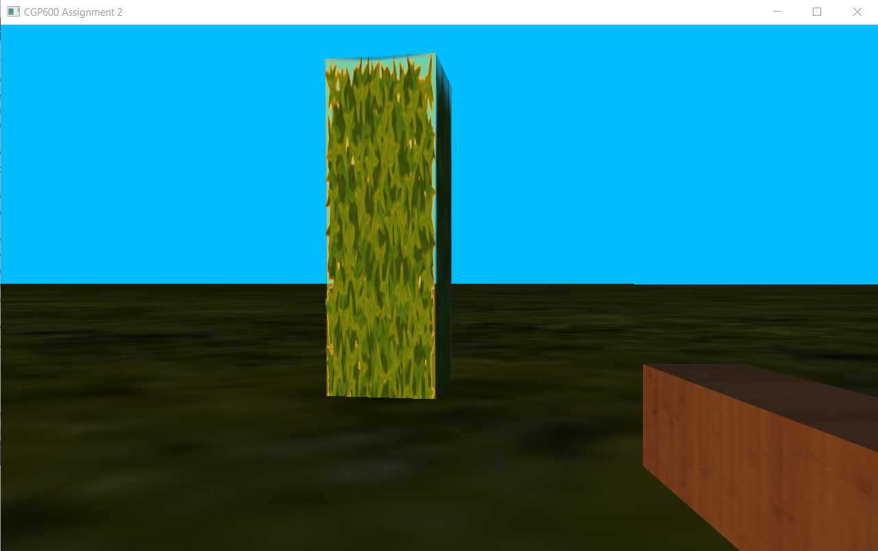

Screenshot 2. Weapon added as a child

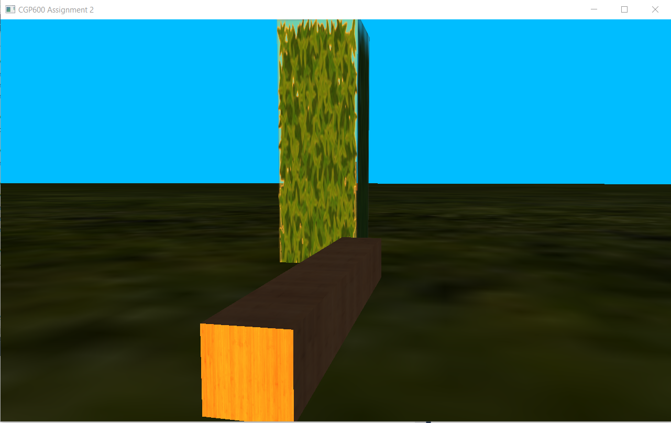

Screenshot 3. Weapon detached from the player

## Multiple Cameras:

The game consists of 2 cameras. First, is the first-person camera from which the player can view and play the game. Second, is a cinematic camera which pauses the entire game and enables the user to freely move around the environment and obtain a better view of it. The player can switch between cameras with a press of a button (see Code Snippet 5). Both the cameras can be seen in Screenshots 4 and 5.

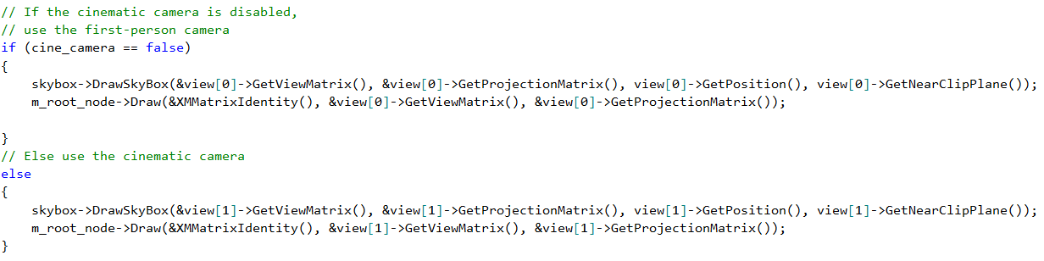

Code Snippet 5. The respective camera will be used

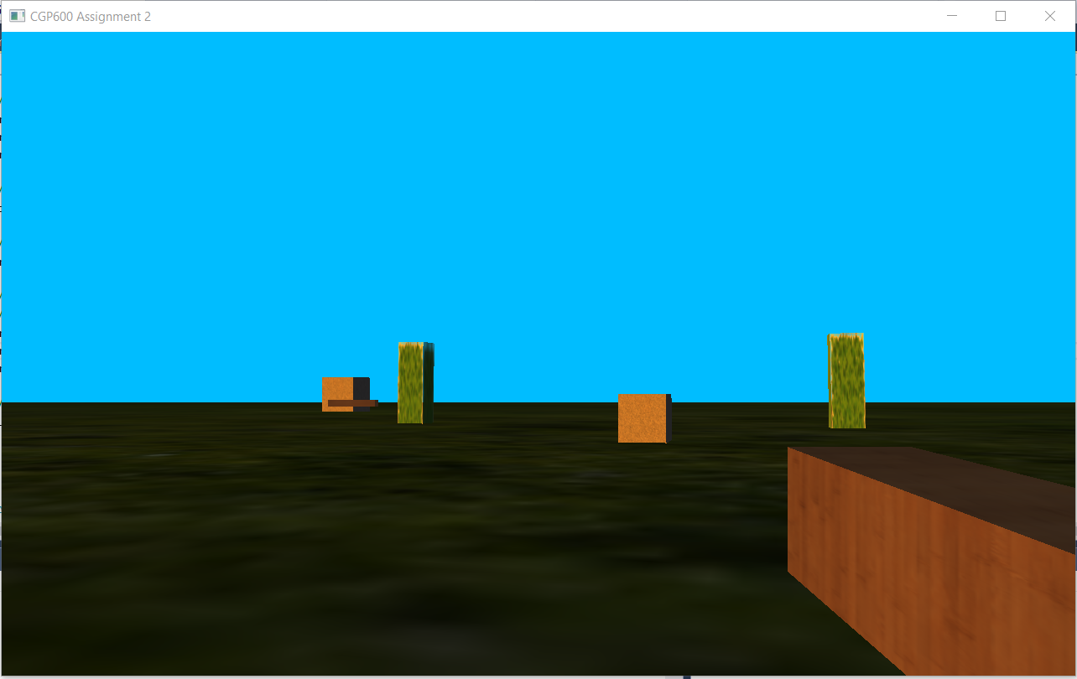

Screenshot 4. First-Person Camera

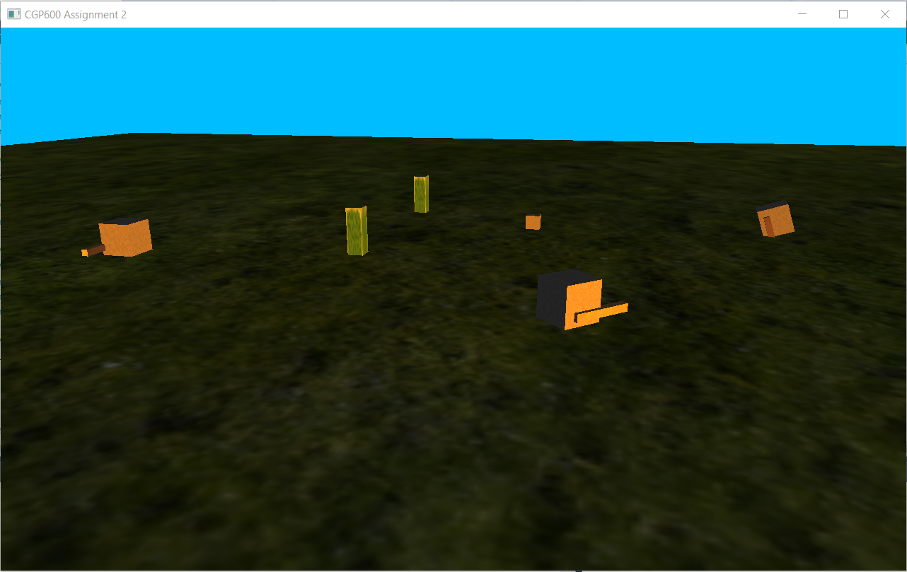

Screenshot 5. Cinematic Camera

## Entity AI:

The only entity in the game are the enemies. They have a fixed number of spots to move towards and when they reach a spot, they move to another randomly chosen spot (see Screenshot 6). As the player approaches an enemy, they abandon their patrol and start moving towards the player (see Screenshot 7). Once, the entity is close enough to the player, they start attacking the player (see Screenshot 8). If the player moves a short distance, they still stop attacking and start to move closer to attack again. If the player flees, they resume their usual patrol. The logic can be seen in Code Snippets 6, 7, and 8.

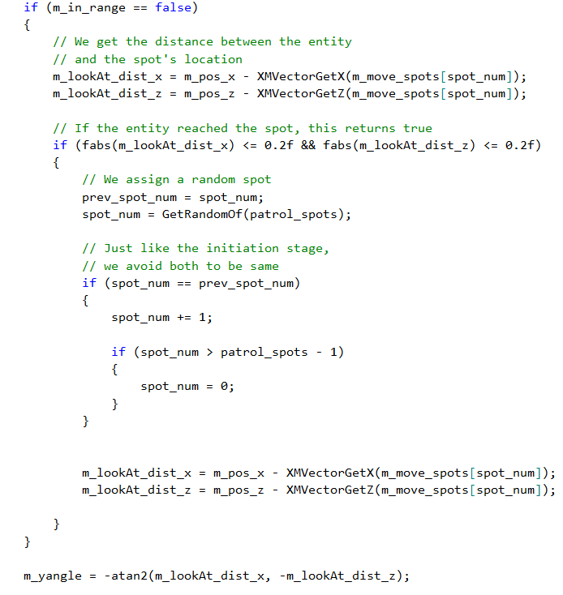

Code Snippet 6. Enemy Patrol Logic

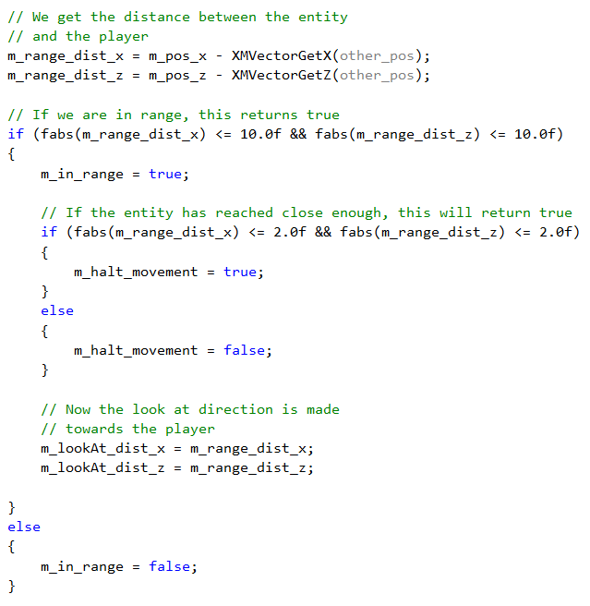

Code Snippet 7. Enemy Approach Logic

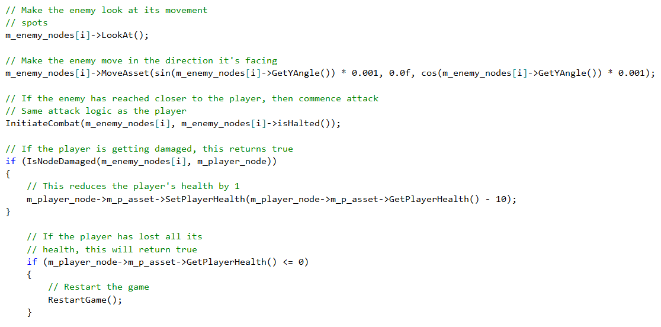

Code Snippet 8. Enemy Attack Logic

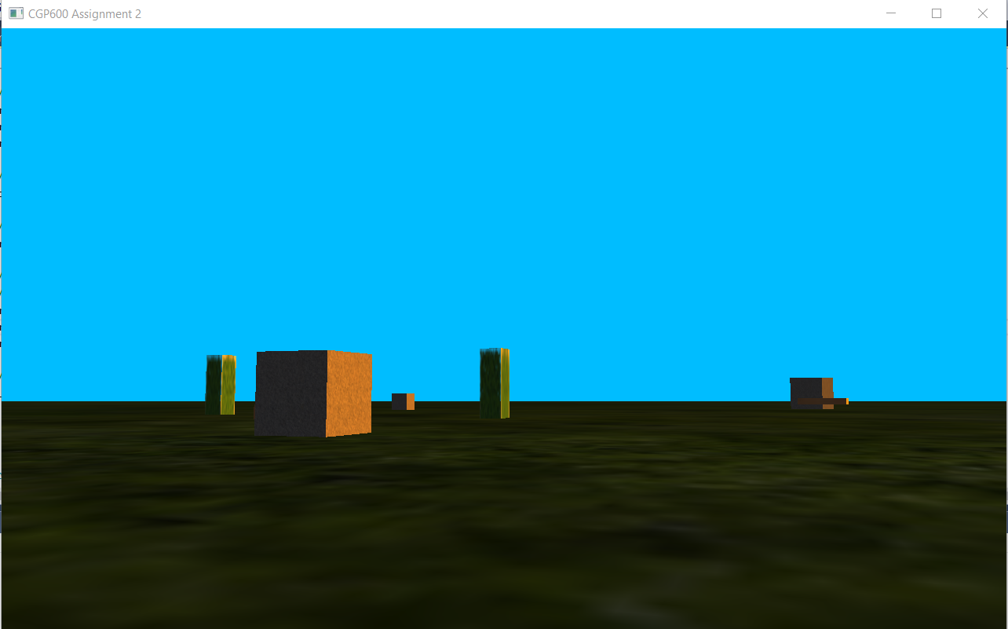

Screenshot 6. Enemy Patrolling

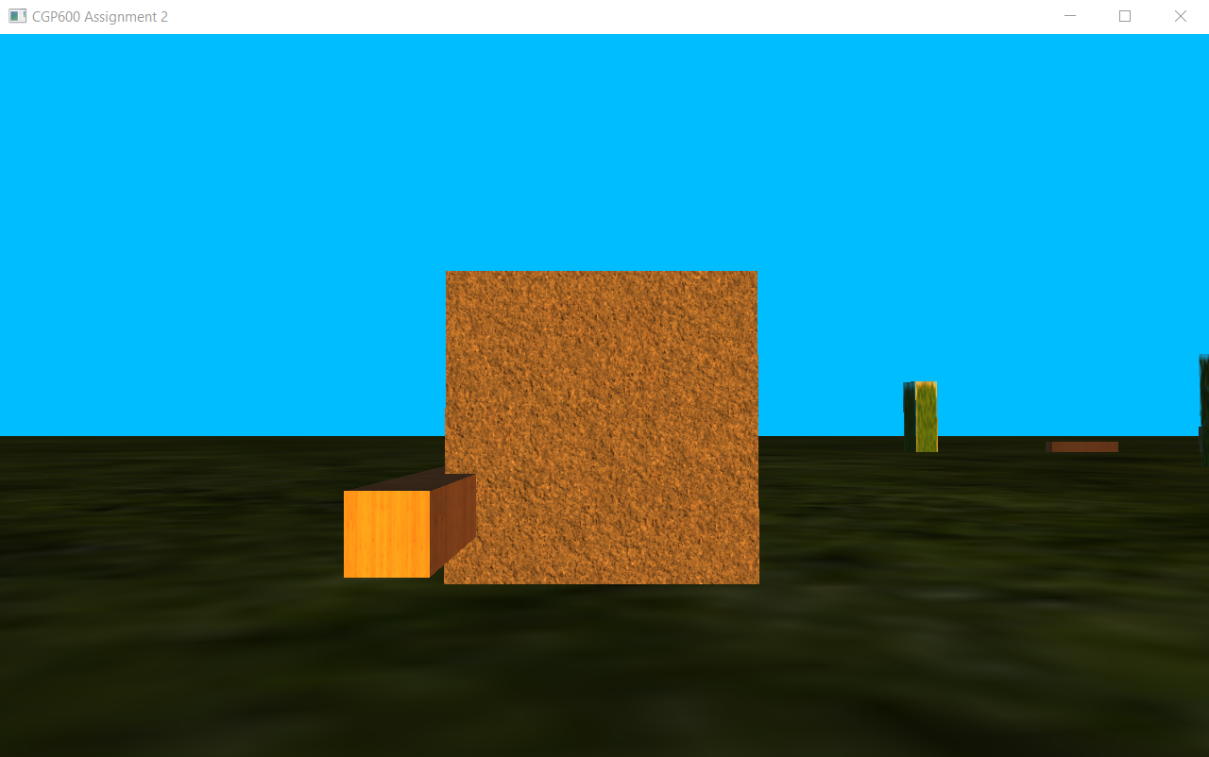

Screenshot 7. Enemy Approaching

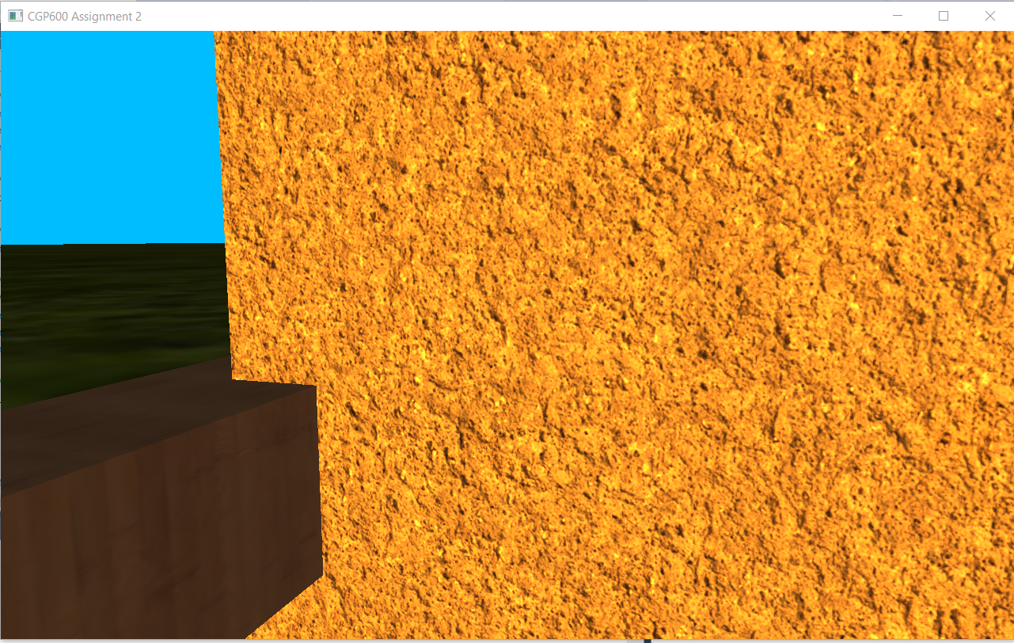

Screenshot 8. Enemy Attacking

## Lighting:

The game consists of a single directional light. It is made to be orange in colour to represent sun at sunset. It is casted diagonally from the left. The implementation can be seen in Screenshots 9 and 10. The logic can be seen in Code Snippets 9 and 10.

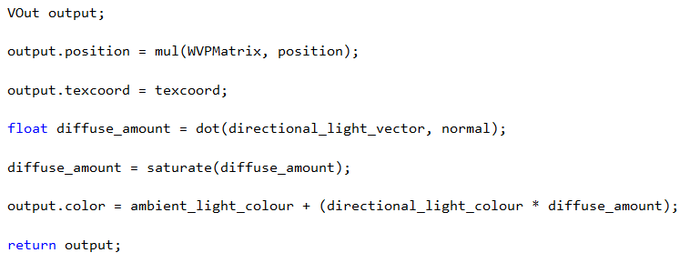

Code Snippet 9. Lighting code in asset shader

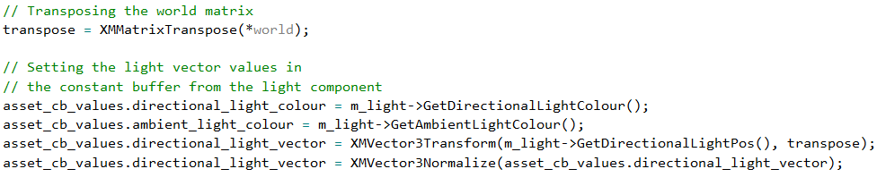

Code Snippet 10. Passing in Light info to the constant buffer

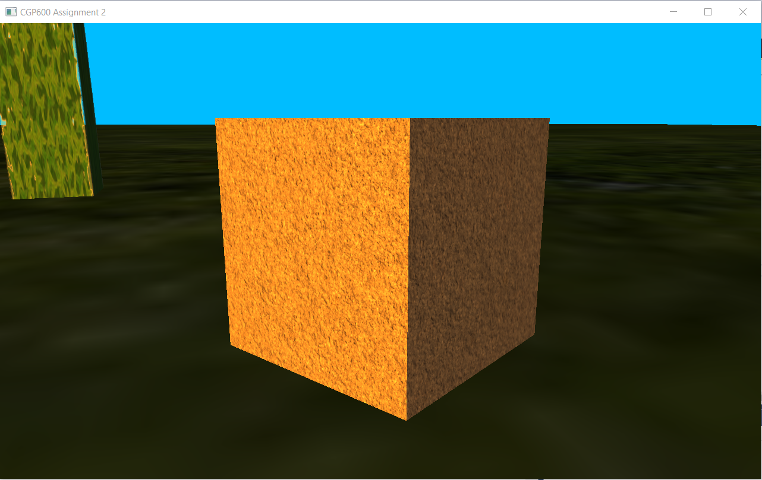

Screenshot 9. Full and partial lighting

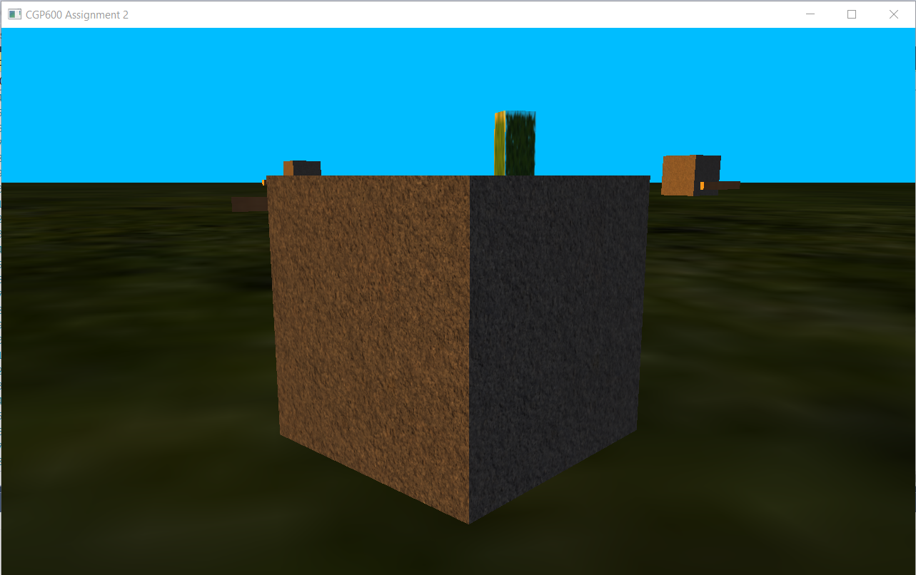

Screenshot 10. Partial and no lighting

# Development Process:

Each concept and technique of DirectX 11 was first developed in separate projects to test them individually. This enabled to understand each concept in clear detail and have a better understanding. Then, a new project was created to put together all the concepts and develop the game at whole. The code was clearly split into various classes and all the relevant details were then declared, initialised, and used appropriately. The newer concepts were also developed separately to ensure it doesn’t disturb the main project. Some of the new concepts were implemented but failed to work. Some of these are UI which had overwritten all other models and textures when rendered (see Screenshot 2) and a skybox texture which failed to load in a texture (see Screenshot 3).



Screenshot 2. The game screen with UI but everything else overwritten

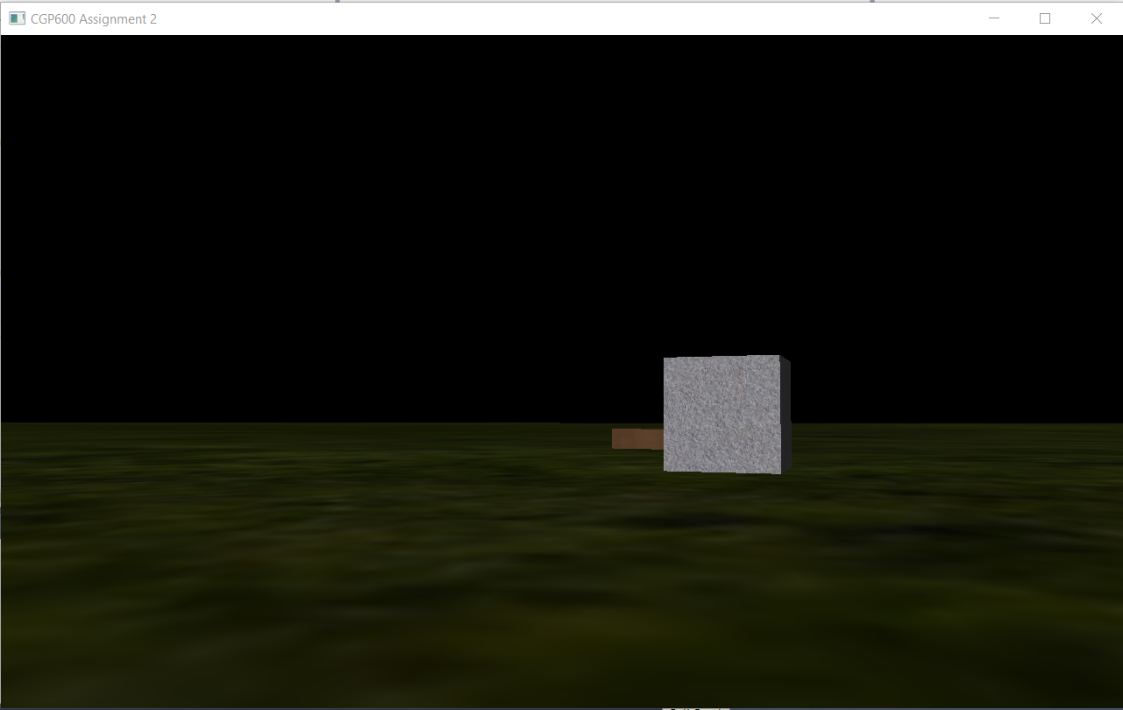

Screenshot 3. The black portion is the skybox but with no texture

# Implementation Changes:

The game was designed to be in third-person, but the game was implemented in first-person. The reason for this change is because the implementation process for third-person proved to be far more complex than the first-person camera. The axis needed to be relative to the player for the camera to rotate around the player and it required a lot of processes. So, the idea of third-person camera was discarded. Moreover, the game was better viewed and played in first-person and provided a lot of ease for the developer to test and play the game.

The game was also designed to have fruits which increases the player’s health. It could have been easily implemented but with the issue of not having UI in the game, the developer was unable to display the player’s health, so the relevant changes could not be displayed.